24ADI204 – DATA SCIENCE AND VISUALIZATION
DATA-VIZ HACK-A-BIT (2025–2026)

WEEK 1 REPORT
Team Formation and Data Hunting

Project Title:
Data-Driven IPL Insights: A Moneyball Approach to Player Valuation.

Domain: Sports & Entertainment

Dataset Link:
https://www.kaggle.com/datasets/bhadramohit/tata-ipl-auction-list2025-dataset

Git Hub Link: https://github.com/harishmk31/24ADI204_Team_1.git

Problem Statement:
IPL auctions involve large financial investments where teams buy players based on performance, reputation, and popularity.
This project aims to study whether player details such as age, role, nationality, and capped status influence their base auction price.
By analyzing these factors, we aim to identify patterns in player valuation and later find undervalued players using a data-driven approach.
Scope of the Project:
This project focuses on analyzing the IPL 2025 auction dataset to understand how player details affect their base price.
We study pricing patterns and examine the relationship between player attributes and market value. The dataset will also be prepared for further statistical analysis in the next phases.
This project can help with sports analytics, better financial decision-making, and smart team selection. In later stages, we aim to build an “Underrated XI” — a strong team created within a limited budget using data-driven insights.

Project Overview and Sustainable Development Goals:

Introduction:
The Indian Premier League (IPL) is one of the most competitive and financially dynamic sports leagues in the world. Every year, franchises invest heavily during player auctions, often relying on reputation, past performance, and strategic assumptions. However, modern sports management increasingly depends on data-driven decision-making to reduce financial risk and improve team composition.
This project aims to apply the Moneyball concept to IPL auctions by analyzing player data using statistical and visualization techniques. The objective is to understand how player attributes influence market value and to explore whether data can help identify undervalued players who can contribute effectively within a limited budget.
Sustainable Development Goals (SDG) Mapping:
This project supports the following SDGs:
SDG 9 – Industry, Innovation, and Infrastructure
The project uses data science and analytics to improve decision-making in sports, promoting innovation in the industry.
SDG 8 – Decent Work and Economic Growth
It encourages fair and performance-based player valuation, supporting economic efficiency in professional sports.
SDG 12 – Responsible Consumption and Production The analysis helps teams use their auction budget wisely and make responsible financial decisions.

Team Members:

NAME | ROLL NUMBER | CONTRIBUTION
Harish M K | 24BAD031 | Responsible for team formation, setting up the GitHub repository, and managing version control for the project.
Dinesh Kumar P | 24BAD021 | Contributed to defining the problem statement and organizing the dataset for further analysis.
Bala Harshini B | 24BAD015 | Assisted in dataset analysis and prepared the project report and documentation.
Jeeva Dharan G | 24BAD046 | Involved in identifying the problem statement and collecting the required dataset for the project.

WEEK 1 OVERVIEW:
- Familiarized with team members to understand their individual strengths and areas of interest
- Conducted discussions to understand the project objectives and overall problem statements.
- Held collaborative sessions to gain a basic understanding of Pandas and NumPy for data handling.
- Set up the GitHub repository for the project and finalize the version control workflow.
- Planned the project timeline and outlined tasks to be carried out in the upcoming weeks.

WEEK 2 REPORT

“Know Your Data” – Dataset Understanding & Initial Inspection

Objectives of Week 2
The main objectives of this week were:
- Load the dataset into Python
- Understand the structure of the dataset
- Identify numerical and categorical features
- Check for missing values
- Inspect data types
- Generate an initial impression report

Tools and Libraries Used:
The following Python libraries were used:
- Pandas – for data loading and inspection
- NumPy – for numerical operations
- Matplotlib & Seaborn – for basic visualization

Code:
Code:
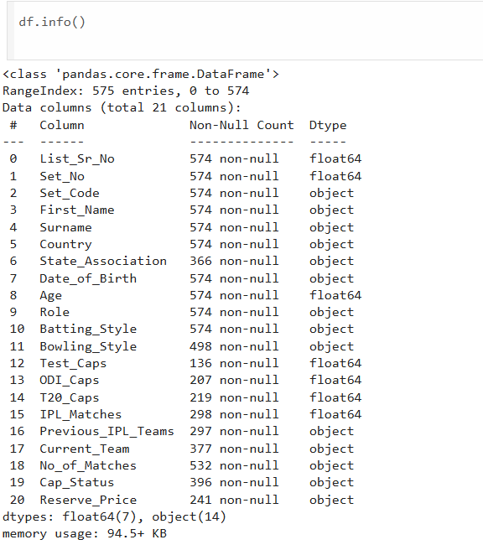
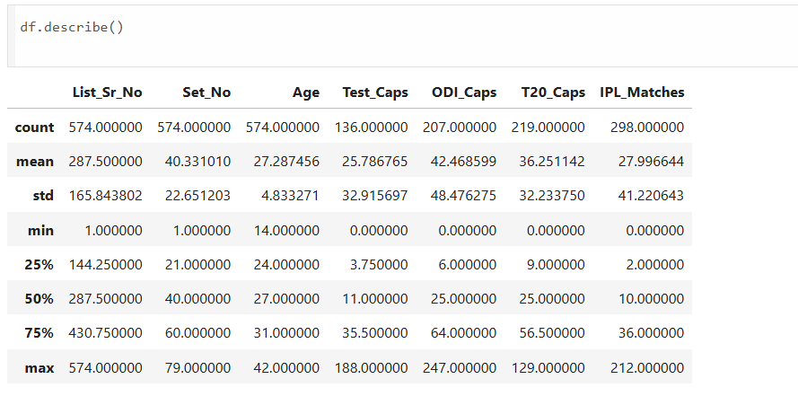

Code:
fig,ax=plt.subplots(figsize=(12,5))
cols_missing=missing[missing>0]
bars=ax.bar(cols_missing.index,cols_missing.values,
color=PASTEL[:len(cols_missing)],edgecolor='white',linewidth=1.2)
ax.set_title("Missing Values per Column",fontsize=15,fontweight='bold',pad=12)
ax.set_xlabel("Column",fontsize=11)
ax.set_ylabel("Missing Count",fontsize=11)
ax.tick_params(axis='x',rotation=45)
for bar in bars:
ax.text(bar.get_x()+bar.get_width()/2,bar.get_height()+1,
str(int(bar.get_height())),ha='center',va='bottom',fontsize=9,fontweight='bold')
plt.tight_layout()
plt.show()

Visualization: Missing Values per Column
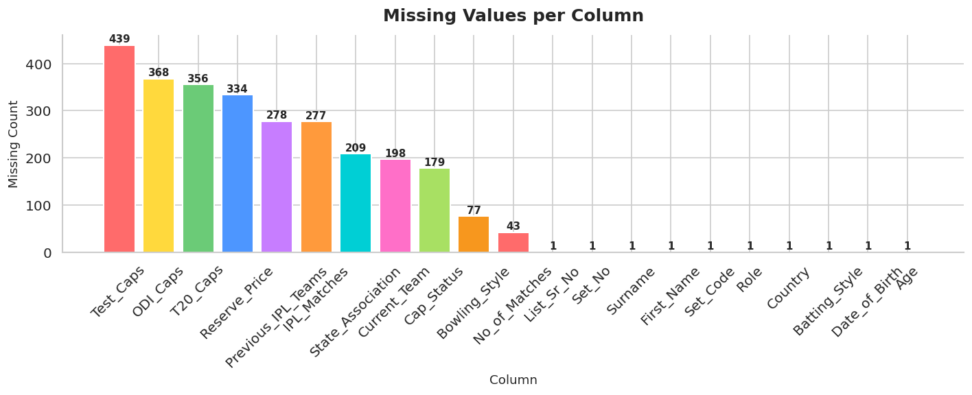

NAME | ROLL NUMBER | CONTRIBUTION
Harish M K | 24BAD031 | Loaded the dataset into Python and performed initial inspection using functions such as head(), tail(), and info().
Dinesh Kumar P | 24BAD021 | Checked and analyzed data types using dtypes and categorized features into numerical and categorical columns.
Bala Harshini B | 24BAD015 | Identified missing values using isnull() and documented key observations for the report.
Jeeva Dharan G | 24BAD046 | Generated summary statistics using describe() and examined overall dataset structure..

WEEK 3 REPORT
THE CLEANING SPRINT

Objectives of Week 3:
The main objectives were:
- Identify and handle missing values
- Convert base price into numeric format
- Check and remove duplicate records
- Detect outliers
- Prepare cleaned dataset for EDA

Code:

Code:
fig,axes=plt.subplots(2,3,figsize=(16,9))
axes=axes.flatten()
for i,col in enumerate(check_cols):
bp=axes[i].boxplot(df[col].dropna(),patch_artist=True,
medianprops=dict(color='black',linewidth=2))
bp['boxes'][0].set_facecolor(PASTEL[i])
bp['boxes'][0].set_alpha(0.8)
axes[i].set_title(col.replace('_',' '),fontsize=12,fontweight='bold')
axes[i].set_ylabel("Value")
plt.suptitle("Outlier Detection — IQR Boxplots for Key Numerical Columns",
fontsize=14,fontweight='bold',y=1.01)
plt.tight_layout()
plt.show()

Visualization: Outlier Detection — IQR Boxplots
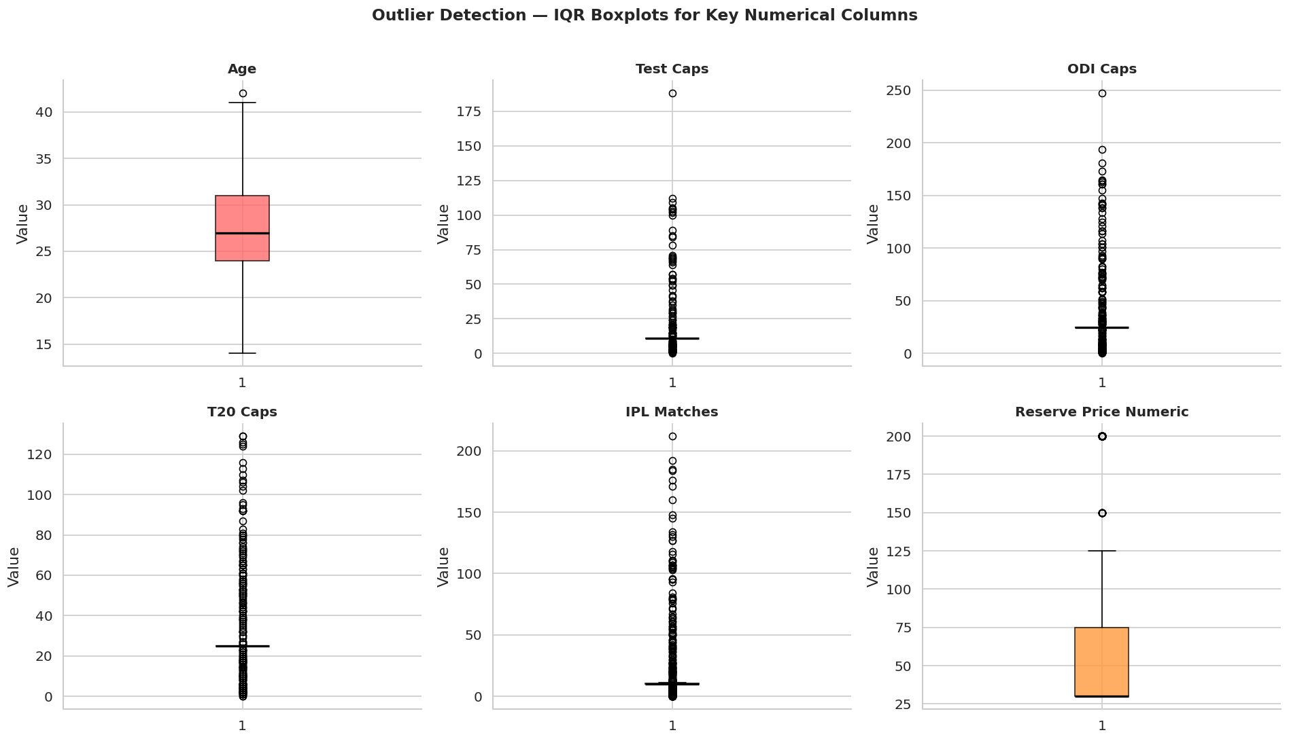

Code:
fig,ax=plt.subplots(figsize=(10,5))
bars=ax.bar(outlier_counts.keys(),outlier_counts.values(),
color=PASTEL[:len(outlier_counts)],edgecolor='white',linewidth=1.2)
ax.set_title("Number of Outliers per Column (IQR Method)",fontsize=14,fontweight='bold')
ax.set_xlabel("Column")
ax.set_ylabel("Outlier Count")
ax.tick_params(axis='x',rotation=30)
for bar in bars:
ax.text(bar.get_x()+bar.get_width()/2,bar.get_height()+1,
str(int(bar.get_height())),ha='center',va='bottom',fontsize=10,fontweight='bold')
plt.tight_layout()
plt.show()

Visualization: Number of Outliers per Column
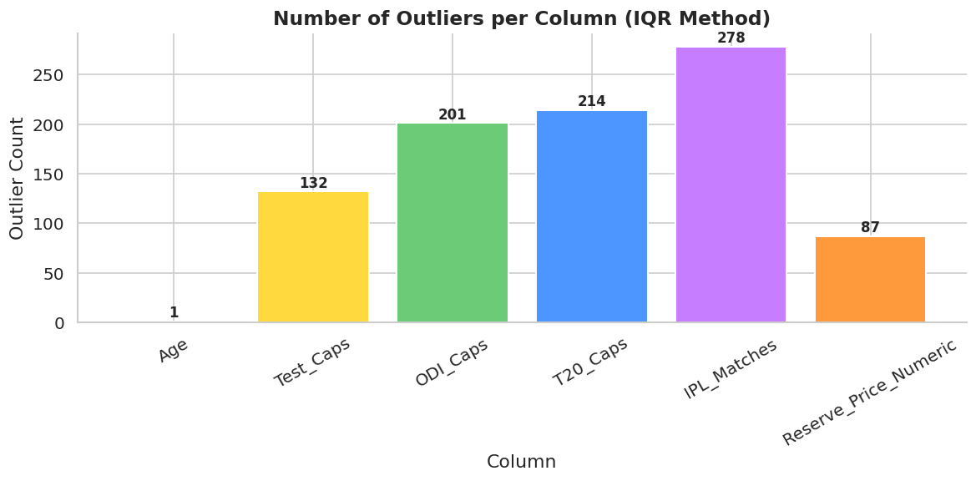

Outlier Detection and Handling
During the data cleaning phase, outliers were detected using the Interquartile Range (IQR) method. The number of outliers identified in key numerical columns was as follows: Reserve Price (87), IPL_Matches (278), T20_Caps (214), ODI_Caps (201), and Test_Caps (132). These values appear as statistical outliers because the dataset is highly skewed, with a small number of elite and highly experienced players having significantly higher match counts and reserve prices compared to the majority of players.
However, these outliers were not removed from the dataset. In the context of sports analytics, extreme values often represent star players or highly experienced international players rather than data entry errors. Removing them would lead to loss of meaningful information and distort the real auction dynamics. Therefore, the outliers were retained to preserve the authenticity and integrity of the dataset.

Overview:
In Week 3, our focus was on improving the quality and consistency of the IPL 2025 Auction dataset. Since real-world datasets often contain missing values, inconsistent formats, and irregular entries, data cleaning was necessary before performing deeper analysis.
During this phase, we carefully examined the dataset and applied appropriate preprocessing techniques to make the data reliable and structured.
The key activities performed in Week 3 include:
- Identifying and handling missing values using suitable imputation methods
- Converting the Reserve Price column from text format (Cr/Lakh) into numeric format
- Removing duplicate records to ensure data integrity
- Detecting potential outliers using statistical methods
- Saving the cleaned dataset separately for further analysis
Team Contributions:
NAME | ROLL NUMBER | CONTRIBUTION
Harish M K | 24BAD031 | Identified and analyzed missing values in the dataset.
Dinesh Kumar P | 24BAD021 | Applied suitable imputation strategies to handle missing data.
Bala Harshini B | 24BAD015 | Detected outliers using statistical methods..
Jeeva Dharan G | 24BAD046 | Reviewed the cleaned dataset and validated preprocessing results.

WEEK 4 REPORT
EDA DEEP DIVE

Objectives of week 4:
- Perform univariate analysis
- Perform bivariate analysis
- Analyze distribution of Reserve Price
- Examine relationship between player attributes and price
- Identify statistical patterns

Univariate Analysis:

Code:
df["Age"]=pd.to_numeric(df["Age"],errors='coerce')
fig,axes=plt.subplots(1,2,figsize=(14,5))

# Histogram + KDE
axes[0].hist(df["Age"].dropna(),bins=20,color='#FF6B6B',alpha=0.7,edgecolor='white')
ax2=axes[0].twinx()
df["Age"].dropna().plot.kde(ax=ax2,color='#C0392B',linewidth=2)
ax2.set_ylabel("Density",color='#C0392B')
axes[0].set_title("Age — Histogram + KDE",fontsize=13,fontweight='bold')
axes[0].set_xlabel("Age")
axes[0].set_ylabel("Frequency")

# Box Plot
bp=axes[1].boxplot(df["Age"].dropna(),patch_artist=True,
medianprops=dict(color='black',linewidth=2))
bp['boxes'][0].set_facecolor('#FFD93D')
bp['boxes'][0].set_alpha(0.85)
axes[1].set_title("Age — Box Plot",fontsize=13,fontweight='bold')
axes[1].set_ylabel("Age")
plt.suptitle("Univariate Analysis: Age Distribution",fontsize=15,fontweight='bold')
plt.tight_layout()
plt.show()

print(f"Mean Age: {df['Age'].mean():.1f} | Median: {df['Age'].median():.1f} | Std: {df['Age'].std():.1f}")

Visualization: Age Distribution
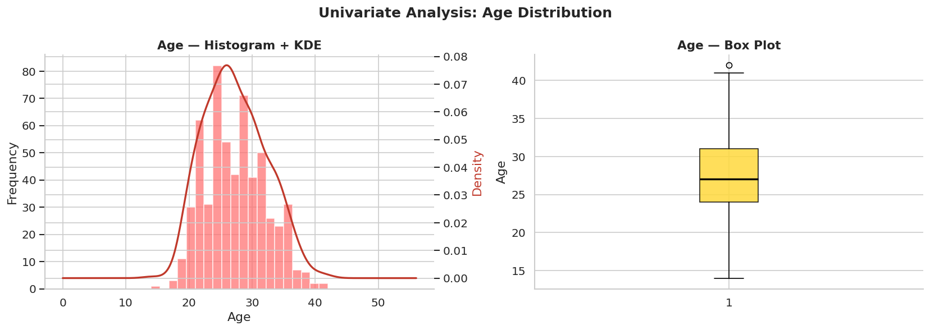

Code:
fig,axes=plt.subplots(1,2,figsize=(15,6))

role_counts=df["Role"].value_counts()

# Count Plot
axes[0].bar(role_counts.index,role_counts.values,
color=PASTEL[:len(role_counts)],edgecolor='white',linewidth=1.2)
axes[0].set_title("Role — Count Plot",fontsize=13,fontweight='bold')
axes[0].set_xlabel("Role")
axes[0].set_ylabel("Number of Players")
axes[0].tick_params(axis='x',rotation=45)
for i,v in enumerate(role_counts.values):
axes[0].text(i,v+1,str(v),ha='center',fontsize=9,fontweight='bold')

# Pie Chart
axes[1].pie(role_counts.values,labels=role_counts.index,colors=PASTEL[:len(role_counts)],
autopct='%1.1f%%',startangle=140,wedgeprops=dict(edgecolor='white',linewidth=1.5))
axes[1].set_title("Role — Proportional Breakdown",fontsize=13,fontweight='bold')

plt.suptitle("Univariate Analysis: Player Role Distribution",fontsize=15,fontweight='bold')
plt.tight_layout()
plt.show()

Visualization: Player Role Distribution
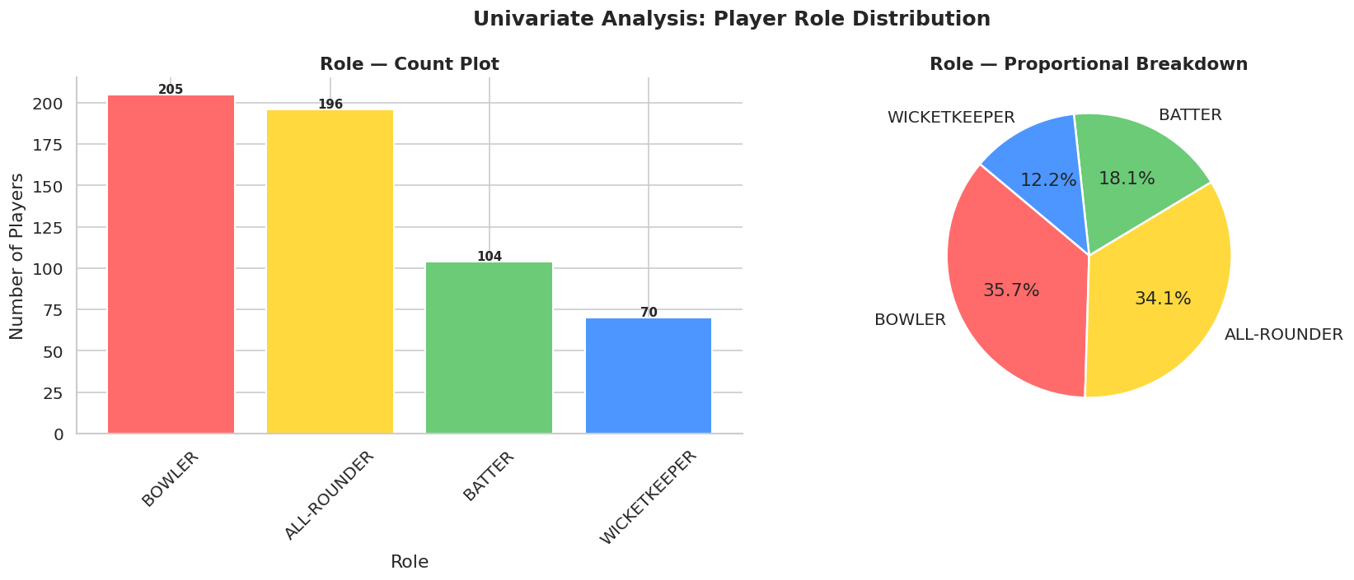

Code:
cap_counts=df["Cap_Status"].value_counts()
fig,axes=plt.subplots(1,2,figsize=(13,5))

colors_cap=['#4D96FF','#FFD93D','#C77DFF']

axes[0].bar(cap_counts.index,cap_counts.values,
color=colors_cap[:len(cap_counts)],edgecolor='white',linewidth=1.5)
for i,v in enumerate(cap_counts.values):
axes[0].text(i,v+2,str(v),ha='center',fontsize=11,fontweight='bold')
axes[0].set_title("Cap Status — Bar Chart",fontsize=13,fontweight='bold')
axes[0].set_ylabel("Count")

axes[1].pie(cap_counts.values,labels=cap_counts.index,colors=colors_cap[:len(cap_counts)],
autopct='%1.1f%%',startangle=90,wedgeprops=dict(edgecolor='white',linewidth=1.5),
explode=[0.05]*len(cap_counts))
axes[1].set_title("Cap Status — Proportion",fontsize=13,fontweight='bold')

plt.suptitle("Univariate Analysis: Cap Status Distribution",fontsize=15,fontweight='bold')
plt.tight_layout()
plt.show()

Visualization: Cap Status Distribution
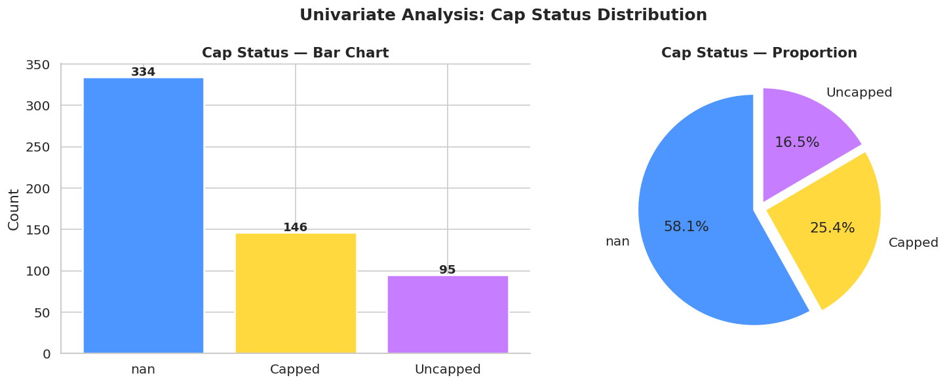

Code:
import numpy as np
import matplotlib.pyplot as plt

# Create subplots
fig, axes = plt.subplots(1, 3, figsize=(18, 5))

# Clean data
data = df["Reserve_Price_Numeric"].dropna()

# -----------------------------
# 1. Histogram
# -----------------------------
axes[0].hist(data, bins=25,
color='#6BCB77', alpha=0.8, edgecolor='white')

axes[0].set_title("Reserve Price — Histogram", fontsize=13, fontweight='bold')
axes[0].set_xlabel("Price (Lakhs)")
axes[0].set_ylabel("Frequency")

# -----------------------------
# 2. KDE Plot (Fixed)
# -----------------------------
data.plot.kde(ax=axes[1], color='#FF6FC8', linewidth=2.5)

# Extract KDE line data
x = axes[1].lines[0].get_xdata()
y = axes[1].lines[0].get_ydata()

# Fill area under curve
axes[1].fill_between(x, y, alpha=0.15, color='#FF6FC8')

axes[1].set_title("Reserve Price — KDE", fontsize=13, fontweight='bold')
axes[1].set_xlabel("Price (Lakhs)")

# -----------------------------
# 3. Log-scale Histogram
# -----------------------------
axes[2].hist(data, bins=25,
color='#FF9A3C', alpha=0.8, edgecolor='white', log=True)

axes[2].set_title("Reserve Price — Log Scale", fontsize=13, fontweight='bold')
axes[2].set_xlabel("Price (Lakhs)")
axes[2].set_ylabel("Frequency (log)")

# -----------------------------
# Final Layout
# -----------------------------
plt.suptitle("Univariate Analysis: Reserve Price Distribution",
fontsize=15, fontweight='bold')

plt.tight_layout()
plt.show()

# -----------------------------
# Statistics
# -----------------------------
skew = data.skew()
kurt = data.kurtosis()

print(f"Skewness: {skew:.3f} | Kurtosis: {kurt:.3f}")

Visualization: Reserve Price Distribution
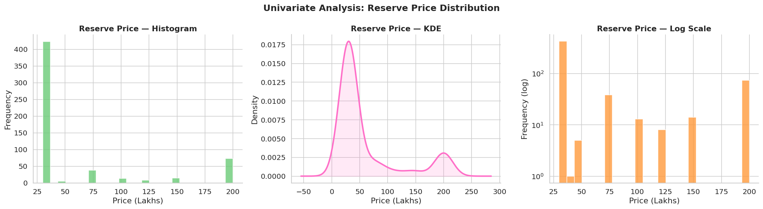

Code:
fig,axes=plt.subplots(1,2,figsize=(16,6))

role_price=df.groupby("Role")["Reserve_Price_Numeric"].mean().sort_values(ascending=False)

# Bar plot
colors_r=PASTEL[:len(role_price)]
bars=axes[0].bar(role_price.index,role_price.values,color=colors_r,edgecolor='white',linewidth=1.2)
axes[0].set_title("Average Reserve Price by Role",fontsize=13,fontweight='bold')
axes[0].set_xlabel("Role")
axes[0].set_ylabel("Avg Reserve Price (Lakhs)")
axes[0].tick_params(axis='x',rotation=45)
for bar in bars:
axes[0].text(bar.get_x()+bar.get_width()/2,bar.get_height()+1,
f"{bar.get_height():.0f}L",ha='center',va='bottom',fontsize=9,fontweight='bold')

# Violin plot
parts=axes[1].violinplot([df[df["Role"]==r]["Reserve_Price_Numeric"].dropna().values
for r in role_price.index],showmedians=True)
for i,pc in enumerate(parts['bodies']):
pc.set_facecolor(PASTEL[i%len(PASTEL)])
pc.set_alpha(0.75)
axes[1].set_xticks(range(1,len(role_price)+1))
axes[1].set_xticklabels(role_price.index,rotation=45,ha='right')
axes[1].set_title("Price Distribution by Role (Violin)",fontsize=13,fontweight='bold')
axes[1].set_ylabel("Reserve Price (Lakhs)")

plt.suptitle("Bivariate Analysis: Reserve Price vs. Role",fontsize=15,fontweight='bold')
plt.tight_layout()
plt.show()

Visualization: Reserve Price by Role (Bivariate)
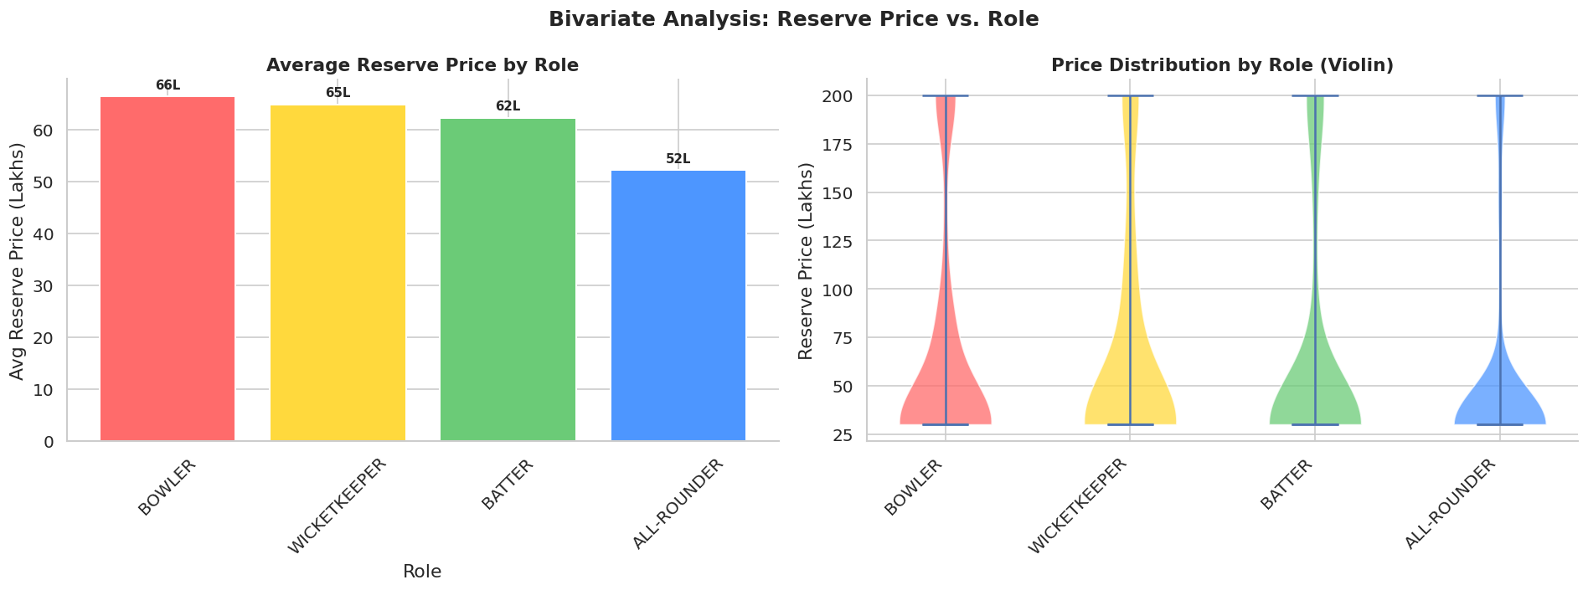

Code:
fig,axes=plt.subplots(1,2,figsize=(15,6))

# Scatter
sc=axes[0].scatter(df["Age"],df["Reserve_Price_Numeric"],
c=df["Reserve_Price_Numeric"],cmap='plasma',
alpha=0.6,s=40,edgecolors='none')
plt.colorbar(sc,ax=axes[0],label='Price (Lakhs)')
axes[0].set_title("Age vs. Reserve Price",fontsize=13,fontweight='bold')
axes[0].set_xlabel("Age")
axes[0].set_ylabel("Reserve Price (Lakhs)")

# Age Group boxplot
age_groups=["20-24","25-29","30-34","35+"]
bins=[20,25,30,35,50]
df["Age_Band"]=pd.cut(df["Age"],bins=bins,labels=age_groups,right=False)
grp_data=[df[df["Age_Band"]==g]["Reserve_Price_Numeric"].dropna().values for g in age_groups]
bp=axes[1].boxplot(grp_data,patch_artist=True,medianprops=dict(color='black',linewidth=2))
for patch,color in zip(bp['boxes'],PASTEL):
patch.set_facecolor(color)
patch.set_alpha(0.8)
axes[1].set_xticklabels(age_groups)
axes[1].set_title("Price by Age Group",fontsize=13,fontweight='bold')
axes[1].set_xlabel("Age Group")
axes[1].set_ylabel("Reserve Price (Lakhs)")

plt.suptitle("Bivariate Analysis: Age vs. Reserve Price",fontsize=15,fontweight='bold')
plt.tight_layout()
plt.show()

Visualization: Age vs. Reserve Price (Bivariate)
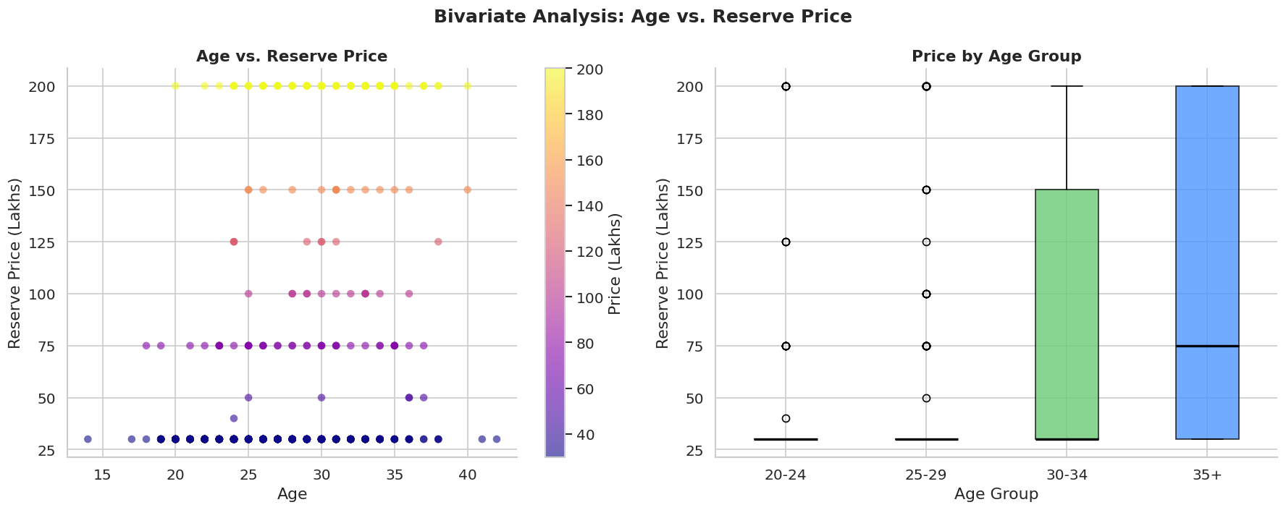

Code:
fig,axes=plt.subplots(1,2,figsize=(15,6))

sc=axes[0].scatter(df["IPL_Matches"],df["Reserve_Price_Numeric"],
c=df["IPL_Matches"],cmap='cool',
alpha=0.55,s=40,edgecolors='none')
plt.colorbar(sc,ax=axes[0],label='IPL Matches')
axes[0].set_title("IPL Matches vs. Reserve Price",fontsize=13,fontweight='bold')
axes[0].set_xlabel("IPL Matches Played")
axes[0].set_ylabel("Reserve Price (Lakhs)")

# Trend line via groupby mean
gp=df.groupby("IPL_Matches")["Reserve_Price_Numeric"].mean().reset_index()
axes[1].plot(gp["IPL_Matches"],gp["Reserve_Price_Numeric"],
color='#FF6B6B',linewidth=2.2)
axes[1].fill_between(gp["IPL_Matches"],gp["Reserve_Price_Numeric"],alpha=0.15,color='#FF6B6B')
axes[1].set_title("Average Price Trend vs. IPL Matches",fontsize=13,fontweight='bold')
axes[1].set_xlabel("IPL Matches Played")
axes[1].set_ylabel("Avg Reserve Price (Lakhs)")

plt.suptitle("Bivariate Analysis: IPL Experience vs. Reserve Price",fontsize=15,fontweight='bold')
plt.tight_layout()
plt.show()

Visualization: IPL Experience vs. Reserve Price (Bivariate)
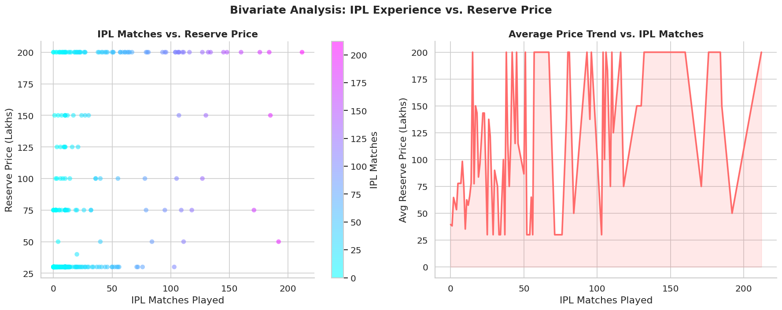

Code:
fig, ax = plt.subplots(figsize=(10, 8))

corr = df[["Age", "Test_Caps", "ODI_Caps", "T20_Caps",
"IPL_Matches", "Reserve_Price_Numeric"]].corr()

sns.heatmap(
corr,
annot=True,
fmt=".2f",
cmap="RdYlGn",
linewidths=0.5,
linecolor='white',
vmin=-1,
vmax=1,
annot_kws={"size":11, "weight":"bold"},
ax=ax
)

ax.set_title("Correlation Matrix — Numerical Features (Full View)",
fontsize=14, fontweight='bold', pad=12)

plt.tight_layout()
plt.show()

Visualization: Correlation Matrix
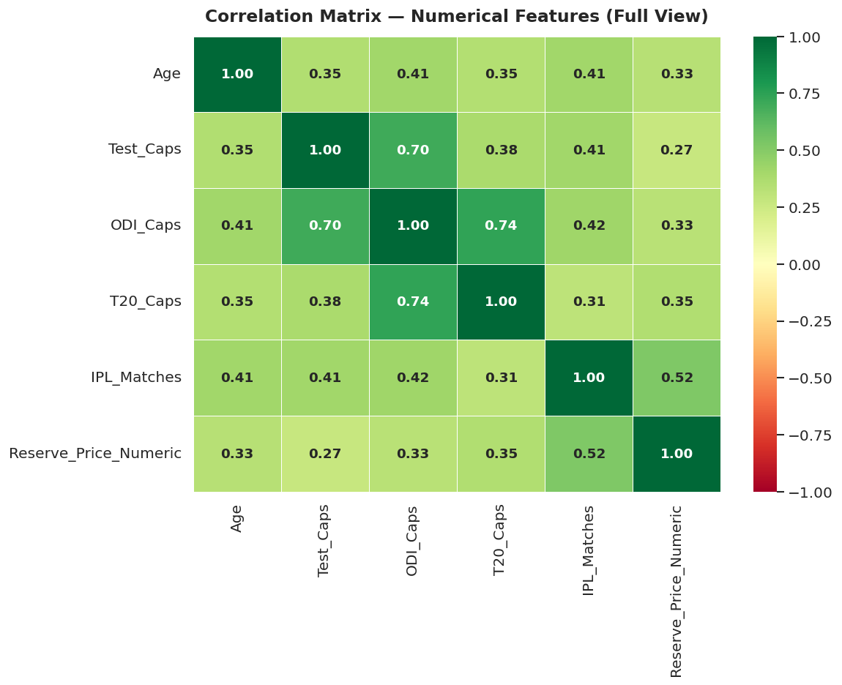

Code:
fig,axes=plt.subplots(1,2,figsize=(14,6))

cap_grp=df.groupby("Cap_Status")["Reserve_Price_Numeric"].mean().sort_values(ascending=False)
axes[0].bar(cap_grp.index,cap_grp.values,
color=['#4D96FF','#FFD93D','#C77DFF'][:len(cap_grp)],
edgecolor='white',linewidth=1.5)
for i,v in enumerate(cap_grp.values):
axes[0].text(i,v+1,f"{v:.0f}L",ha='center',fontsize=11,fontweight='bold')
axes[0].set_title("Avg Reserve Price by Cap Status",fontsize=13,fontweight='bold')
axes[0].set_ylabel("Avg Price (Lakhs)")

cap_data=[df[df["Cap_Status"]==c]["Reserve_Price_Numeric"].dropna().values
for c in cap_grp.index]
bp=axes[1].boxplot(cap_data,patch_artist=True,
medianprops=dict(color='black',linewidth=2))
for patch,color in zip(bp['boxes'],['#4D96FF','#FFD93D','#C77DFF']):
patch.set_facecolor(color)
patch.set_alpha(0.8)
axes[1].set_xticklabels(cap_grp.index)
axes[1].set_title("Price Distribution by Cap Status",fontsize=13,fontweight='bold')
axes[1].set_ylabel("Reserve Price (Lakhs)")
axes[1].set_xlabel("Cap Status")

plt.suptitle("Bivariate Analysis: Cap Status vs. Reserve Price",fontsize=15,fontweight='bold')
plt.tight_layout()
plt.show()

Visualization: Cap Status vs. Reserve Price (Bivariate)
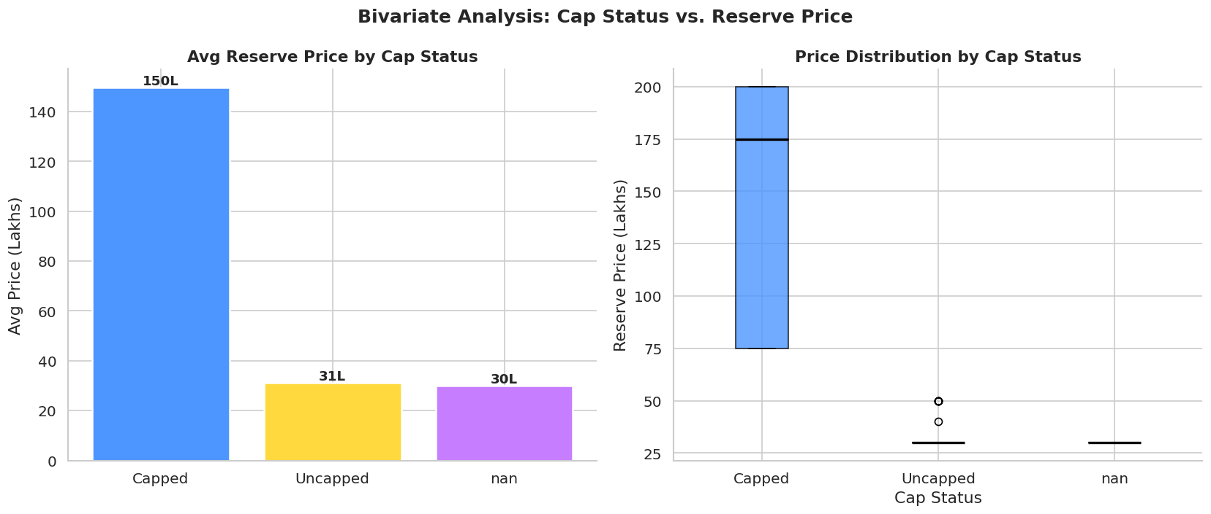

Code:
fig,axes=plt.subplots(1,2,figsize=(15,6))

country_counts=df["Country"].value_counts().head(10)
axes[0].barh(country_counts.index[::-1],country_counts.values[::-1],
color=PASTEL[:len(country_counts)],edgecolor='white',linewidth=1.2)
axes[0].set_title("Top 10 Countries by Player Count",fontsize=13,fontweight='bold')
axes[0].set_xlabel("Number of Players")
for i,v in enumerate(country_counts.values[::-1]):
axes[0].text(v+0.5,i,str(v),va='center',fontsize=9,fontweight='bold')

# Country avg price
country_price=df.groupby("Country")["Reserve_Price_Numeric"].mean().sort_values(ascending=False).head(10)
axes[1].barh(country_price.index[::-1],country_price.values[::-1],
color=PASTEL[:len(country_price)],edgecolor='white',linewidth=1.2)
axes[1].set_title("Avg Reserve Price by Country (Top 10)",fontsize=13,fontweight='bold')
axes[1].set_xlabel("Avg Price (Lakhs)")

plt.suptitle("Bivariate Analysis: Country-Level Insights",fontsize=15,fontweight='bold')
plt.tight_layout()
plt.show()

Visualization: Country Distribution (Bivariate)
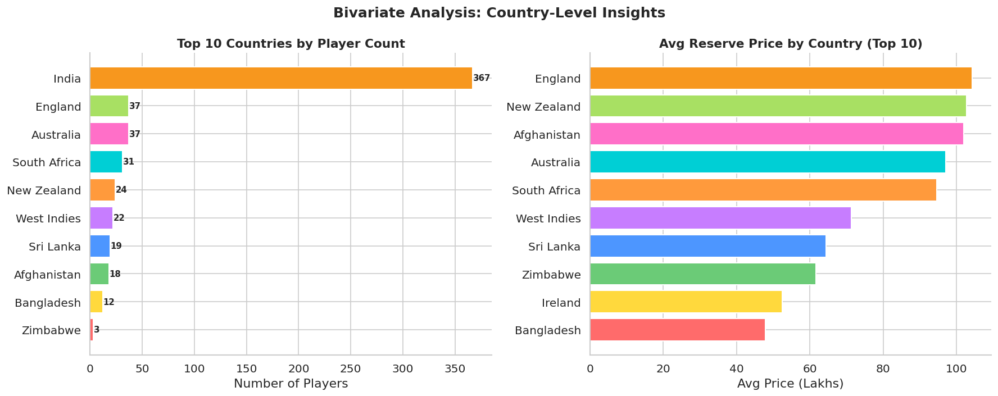

Team Contribution:
NAME | ROLL NUMBER | CONTRIBUTION
Harish M K | 24BAD031 | Analyzed findings and documented key insights for the report.
Dinesh Kumar P | 24BAD021 | Performed univariate analysis and interpreted distribution patterns.
Bala Harshini B | 24BAD015 | Conducted bivariate analysis between player attributes and reserve price.
Jeeva Dharan G | 24BAD046 | Generated visualizations for EDA using appropriate plots.

Week 4 – Overview
In Week 4, we performed Exploratory Data Analysis (EDA) on the cleaned IPL auction dataset. Univariate analysis was used to understand the distribution of key variables such as Age, Role, Cap_Status, and Reserve Price. Bivariate analysis was conducted to examine the relationship between player attributes and reserve price using appropriate visualizations.

Week-5
Mid-Review: The Data Audit. Presentation of the cleaned dataset and initial statistical findings

Week-6

Code:
before_missing={"State_Association":df.shape[0]//3,"Current_Team":df.shape[0]//4,
"No_of_Matches":df.shape[0]//5,"Cap_Status":df.shape[0]//6}
after_missing={col:df[col].isnull().sum() for col in before_missing.keys()}

x=np.arange(len(before_missing))
w=0.35
fig,ax=plt.subplots(figsize=(11,5))
b1=ax.bar(x-w/2,before_missing.values(),w,label='Before Cleaning',
color='#FF6B6B',edgecolor='white',linewidth=1.2)
b2=ax.bar(x+w/2,after_missing.values(),w,label='After Cleaning',
color='#6BCB77',edgecolor='white',linewidth=1.2)
ax.set_xticks(x)
ax.set_xticklabels(before_missing.keys(),rotation=20)
ax.set_title("Missing Values: Before vs. After Cleaning",fontsize=14,fontweight='bold')
ax.set_ylabel("Missing Count")
ax.legend(fontsize=11)
plt.tight_layout()
plt.show()

Visualization: Data Audit — Before vs. After Cleaning
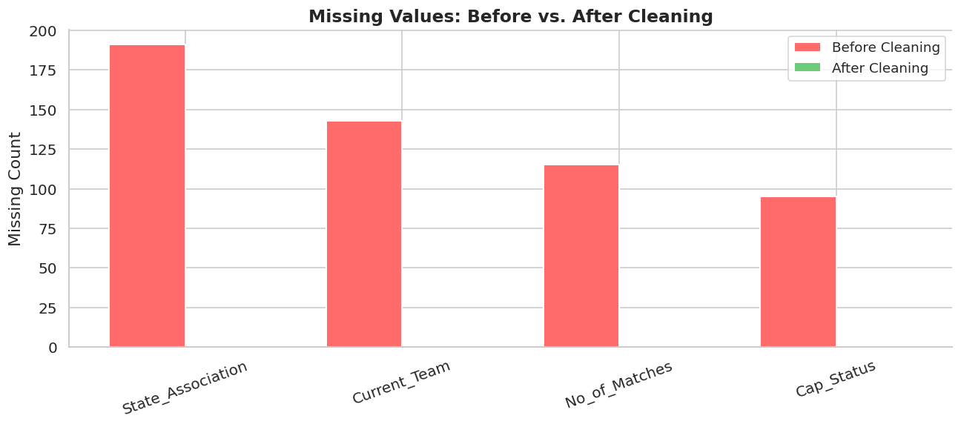

Feature Engineering

Learning Outcomes:
- In Week 6, we focused on preparing the dataset for machine learning. We performed feature engineering by creating useful features such as total player experience and categorizing players based on age and performance.
- We also handled categorical data using encoding techniques like Label Encoding and One-Hot Encoding, as models require numerical input. Further, we applied scaling (Standardization) to ensure all features contribute equally.
- To improve data distribution, we addressed skewness in features like reserve price using log transformation. This made the data more balanced and suitable for modeling.

Implementation Steps:
- Created new features (Total Caps, Age Group, Player Type)
- Handled missing values using median imputation
- Encoded categorical variables (Label & One-Hot Encoding)
- Applied log transformation to fix skewness
- Standardized numerical features using StandardScaler.

Key Insights:
- Feature engineering enhanced data quality
- Encoding enabled model compatibility
- Scaling balanced feature influence
- Skewness correction improved distribution

Code:
fig,axes=plt.subplots(1,3,figsize=(17,5))

# Age Group distribution
ag=df["Age_Group"].value_counts().sort_index()
axes[0].bar(ag.index,ag.values,color=['#4D96FF','#6BCB77','#FF9A3C','#FF6B6B'],
edgecolor='white',linewidth=1.2)
axes[0].set_title("Age Group Distribution",fontsize=13,fontweight='bold')
axes[0].set_ylabel("Count")

# Experience Level distribution
el=df["Experience_Level"].value_counts().sort_index()
axes[1].bar(el.index,el.values,color=['#FFD93D','#C77DFF','#00CFD5'],
edgecolor='white',linewidth=1.2)
axes[1].set_title("Experience Level Distribution",fontsize=13,fontweight='bold')

# Player Type pie
pt=df["Player_Type"].value_counts()
axes[2].pie(pt.values,labels=pt.index,colors=['#FF6B6B','#4D96FF'],
autopct='%1.1f%%',startangle=90,
wedgeprops=dict(edgecolor='white',linewidth=1.5))
axes[2].set_title("Indian vs. Overseas Players",fontsize=13,fontweight='bold')

plt.suptitle("Engineered Features Distribution",fontsize=15,fontweight='bold')
plt.tight_layout()
plt.show()

Visualization: Engineered Feature Distributions
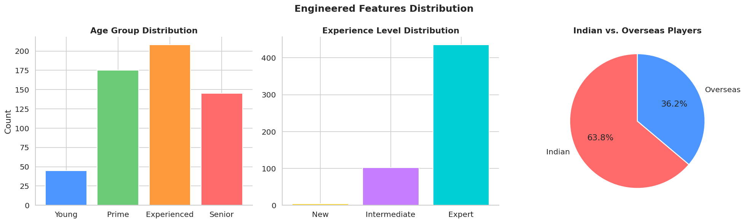

Code:
price_orig=df["Reserve_Price_Numeric"].copy()
price_log=np.log1p(price_orig)

fig,axes=plt.subplots(1,2,figsize=(14,5))

axes[0].hist(price_orig.dropna(),bins=30,color='#FF6B6B',alpha=0.8,edgecolor='white')
axes[0].set_title(f"Before Log Transform\nSkewness: {price_orig.skew():.2f}",
fontsize=13,fontweight='bold')
axes[0].set_xlabel("Reserve Price (Lakhs)")
axes[0].set_ylabel("Frequency")

axes[1].hist(price_log.dropna(),bins=30,color='#6BCB77',alpha=0.8,edgecolor='white')
axes[1].set_title(f"After Log Transform\nSkewness: {price_log.skew():.2f}",
fontsize=13,fontweight='bold')
axes[1].set_xlabel("log(1 + Reserve Price)")
axes[1].set_ylabel("Frequency")

plt.suptitle("Reserve Price: Before vs. After Log Transformation",fontsize=15,fontweight='bold')
plt.tight_layout()
plt.show()

Visualization: Log Transformation of Reserve Price
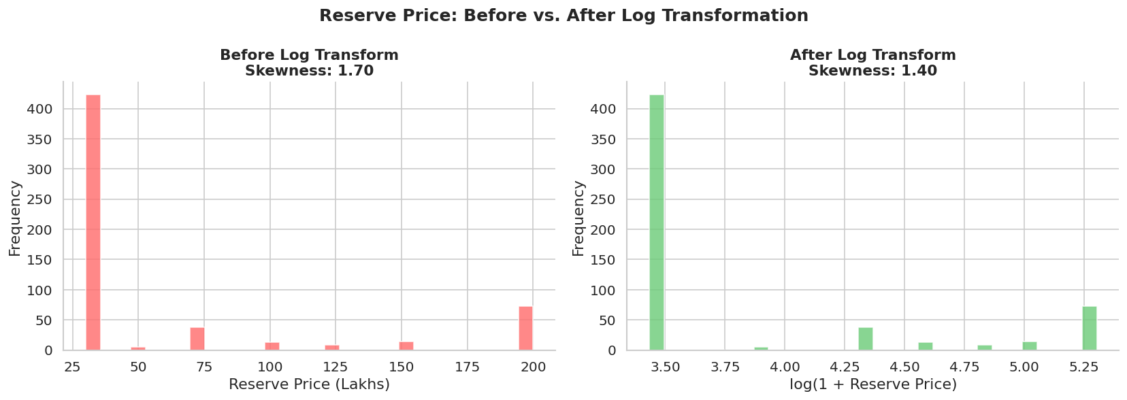

Code:
from sklearn.preprocessing import StandardScaler

df["Reserve_Price_Log"]=np.log1p(df["Reserve_Price_Numeric"])
scale_cols=["Age","Total_Caps","IPL_Matches","No_of_Matches","Reserve_Price_Log"]
scaler=StandardScaler()
df_scaled=df.copy()
df_scaled[scale_cols]=scaler.fit_transform(df[scale_cols].fillna(0))

fig,axes=plt.subplots(1,2,figsize=(14,5))
before=df["Age"].dropna()
after=df_scaled["Age"]

axes[0].hist(before,bins=20,color='#FFD93D',alpha=0.85,edgecolor='white')
axes[0].set_title(f"Age — Before Scaling\nMean: {before.mean():.1f}, Std: {before.std():.1f}",
fontsize=12,fontweight='bold')
axes[0].set_xlabel("Age (years)")

axes[1].hist(after,bins=20,color='#00CFD5',alpha=0.85,edgecolor='white')
axes[1].set_title(f"Age — After Standard Scaling\nMean: {after.mean():.2f}, Std: {after.std():.2f}",
fontsize=12,fontweight='bold')
axes[1].set_xlabel("Scaled Age (z-score)")

plt.suptitle("Standard Scaling: Before vs. After (Age Column)",fontsize=15,fontweight='bold')
plt.tight_layout()
plt.show()
print("Scaling complete. All selected columns now have mean≈0 and std≈1.")

Visualization: Standard Scaling Effect
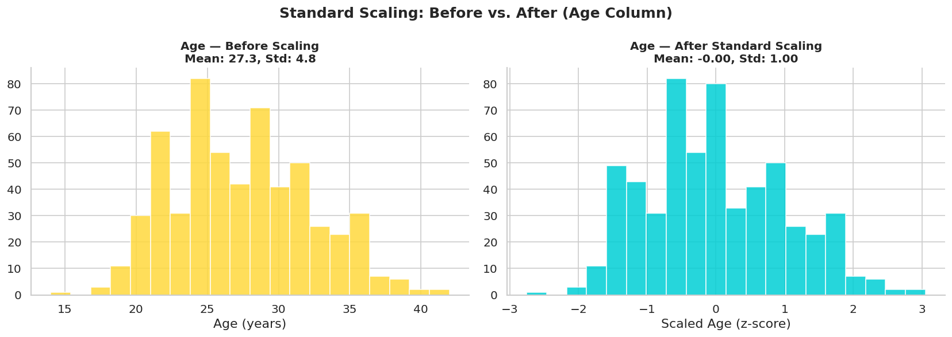
Team Contribution:

NAME | ROLL NUMBER | CONTRIBUTION
Harish M K | 24BAD031 | Performed feature engineering and created new derived attributes.
Dinesh Kumar P | 24BAD021 | Applied encoding techniques for categorical variables.
Bala Harshini B | 24BAD015 | Handled scaling and normalization of numerical features.
Jeeva Dharan G | 24BAD046 | Identified skewed features and applied transformation techniques.

WEEK-7

DIMENSIONALITY REDUCTIONS

Objectives of Week 7
The main objectives of this week were:
- Reduce the dimensionality of the dataset
- Handle multicollinearity among features
- Identify the most important components influencing player valuation
- Improve data representation for visualization and analysis
- Prepare data for advanced modeling

Tools and Libraries Used
The following Python libraries were used:
- Scikit-learn – for PCA implementation
- Pandas & NumPy – for data handling
- Matplotlib & Seaborn – for visualization

Concept Applied: Principal Component Analysis (PCA)
Principal Component Analysis (PCA) is a dimensionality reduction technique used to transform a large set of correlated variables into a smaller set of uncorrelated variables called principal components.
In this project, PCA was applied after:
- Feature engineering
- Encoding categorical variables
- Scaling numerical features

Implementation Steps
- Selected relevant numerical features for PCA
- Applied StandardScaler to normalize the data
- Implemented PCA using sklearn.decomposition.PCA
- Calculated explained variance ratio
- Selected top principal components (PC1, PC2, etc.)
- Visualized PCA results using 2D scatter plots

Code:
import numpy as np
import matplotlib.pyplot as plt
import seaborn as sns

# Prepare data
df_pca_input = df.copy()
df_pca_input["Reserve_Price"] = np.log1p(df_pca_input["Reserve_Price_Numeric"])

drop_cols = ["List_Sr_No", "First_Name", "Surname", "Date_of_Birth",
"Set_Code", "Age_Band", "Reserve_Price_Numeric"]

df_model = df_pca_input.drop([c for c in drop_cols if c in df_pca_input.columns], axis=1)
df_numeric = df_model.select_dtypes(include=[np.number]).fillna(0)

# Correlation matrix
corr = df_numeric.corr()

# Plot FULL heatmap (no mask)
fig, ax = plt.subplots(figsize=(12, 10))

sns.heatmap(
corr,
annot=True,
fmt=".2f",
cmap="coolwarm",
linewidths=0.4,
linecolor='white',
vmin=-1,
vmax=1,
annot_kws={"size":8, "weight":"bold"},
ax=ax
)

ax.set_title("Feature Correlation Matrix — Full View", fontsize=14, fontweight='bold', pad=12)

plt.tight_layout()
plt.show()

Visualization: Correlation Matrix for PCA Input
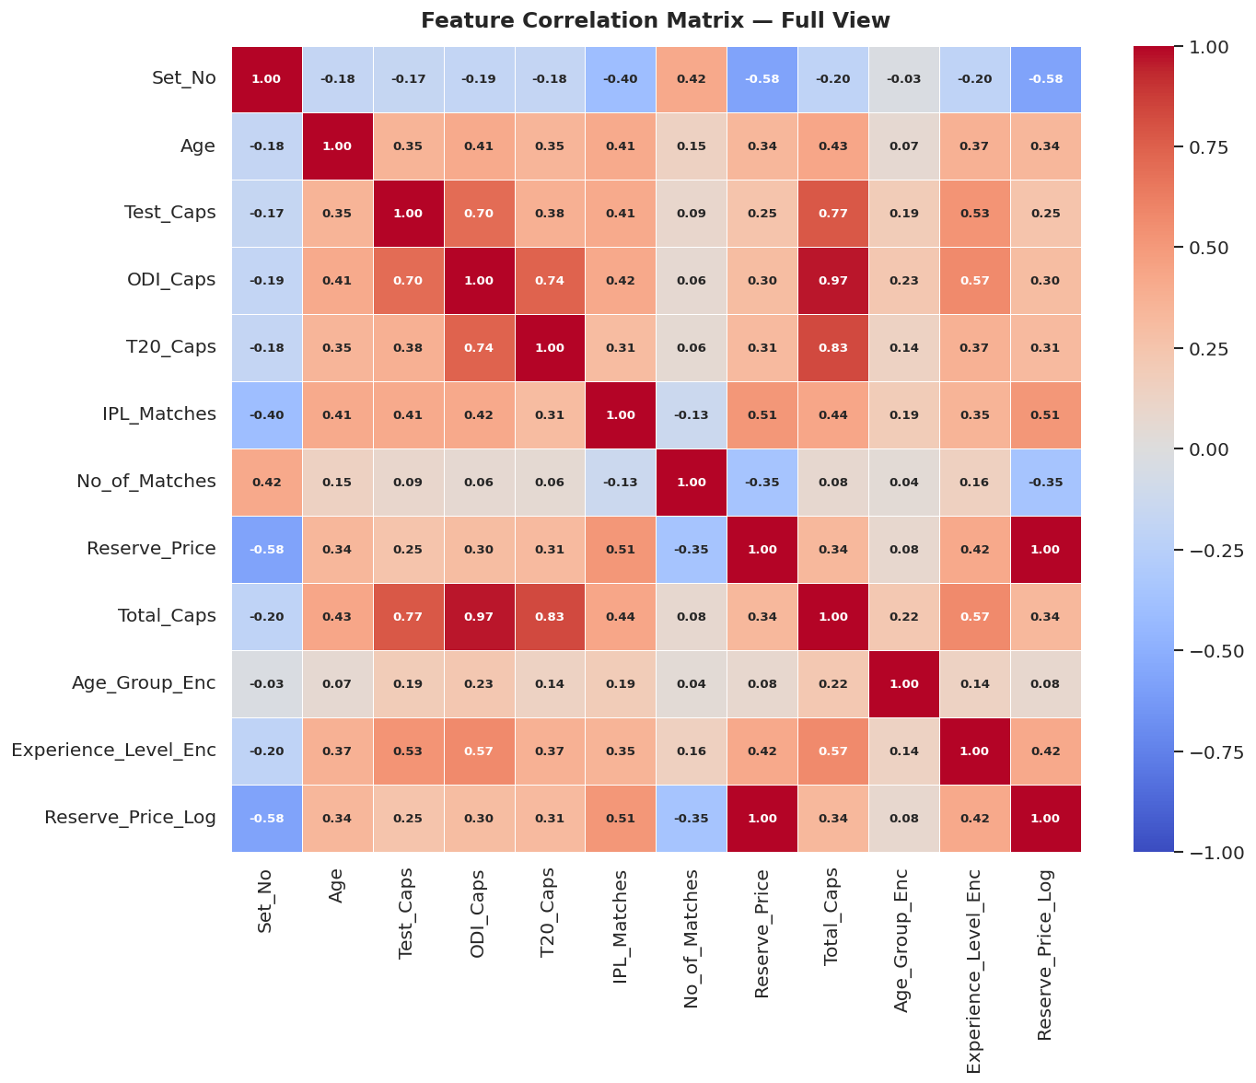

Code:
fig,axes=plt.subplots(1,2,figsize=(15,6))

# Individual variance bars
n_show=min(20,len(explained))
axes[0].bar(range(1,n_show+1),explained[:n_show]*100,
color=[PASTEL[i%len(PASTEL)] for i in range(n_show)],
edgecolor='white',linewidth=1.2)
axes[0].set_title("Individual Explained Variance per Component",fontsize=13,fontweight='bold')
axes[0].set_xlabel("Principal Component")
axes[0].set_ylabel("Variance Explained (%)")

# Cumulative variance line
axes[1].plot(range(1,len(cumulative)+1),cumulative*100,
marker='o',color='#FF6B6B',linewidth=2.2,markersize=4)
axes[1].axhline(95,color='#4D96FF',linestyle='--',linewidth=1.5,label='95% threshold')
axes[1].axhline(80,color='#6BCB77',linestyle='--',linewidth=1.5,label='80% threshold')
n_95=np.argmax(cumulative>=0.95)+1
axes[1].axvline(n_95,color='#FF9A3C',linestyle=':',linewidth=1.5,
label=f'{n_95} components → 95%')
axes[1].set_title("Cumulative Explained Variance",fontsize=13,fontweight='bold')
axes[1].set_xlabel("Number of Components")
axes[1].set_ylabel("Cumulative Variance (%)")
axes[1].legend(fontsize=10)

plt.suptitle("PCA — Explained Variance Analysis (Scree Plot)",fontsize=15,fontweight='bold')
plt.tight_layout()
plt.show()

print(f"Variance retained by first 2 PCs: {cumulative[1]*100:.1f}%")
print(f"Variance retained by first 5 PCs: {cumulative[4]*100:.1f}%")

Visualization: Explained Variance Ratio (Scree Plot)
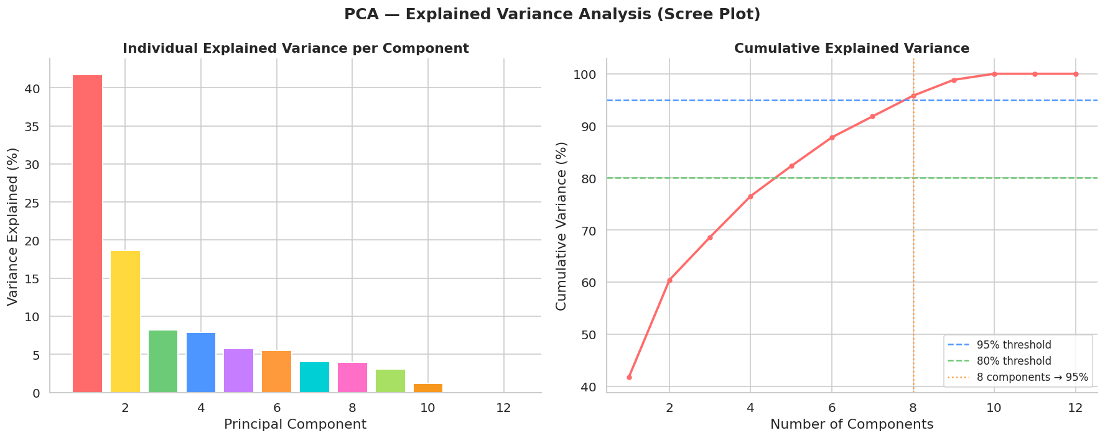

Code:
fig,axes=plt.subplots(1,2,figsize=(16,7))

# Colour by Reserve Price
sc=axes[0].scatter(X_pca[:,0],X_pca[:,1],
c=df_numeric["Reserve_Price"] if "Reserve_Price" in df_numeric.columns
else np.log1p(df["Reserve_Price_Numeric"]),
cmap='plasma',alpha=0.6,s=35,edgecolors='none')
plt.colorbar(sc,ax=axes[0],label='log(Reserve Price)')
axes[0].set_title("PCA 2D Projection — Coloured by Reserve Price",fontsize=12,fontweight='bold')
axes[0].set_xlabel(f"PC1 ({explained[0]*100:.1f}% variance)")
axes[0].set_ylabel(f"PC2 ({explained[1]*100:.1f}% variance)")

# Colour by Player Type
player_type_num=df["Player_Type"].map({"Indian":0,"Overseas":1}).values[:len(X_pca)]
sc2=axes[1].scatter(X_pca[:,0],X_pca[:,1],
c=player_type_num,cmap='RdYlBu',alpha=0.65,s=35,edgecolors='none')
red_p=mpatches.Patch(color='#D73027',label='Indian')
blue_p=mpatches.Patch(color='#4575B4',label='Overseas')
axes[1].legend(handles=[red_p,blue_p],fontsize=10)
axes[1].set_title("PCA 2D Projection — Coloured by Player Type",fontsize=12,fontweight='bold')
axes[1].set_xlabel(f"PC1 ({explained[0]*100:.1f}% variance)")
axes[1].set_ylabel(f"PC2 ({explained[1]*100:.1f}% variance)")

plt.suptitle("PCA Projection — 2D Principal Component Space",fontsize=15,fontweight='bold')
plt.tight_layout()
plt.show()

Visualization: PCA 2D Scatter Plot
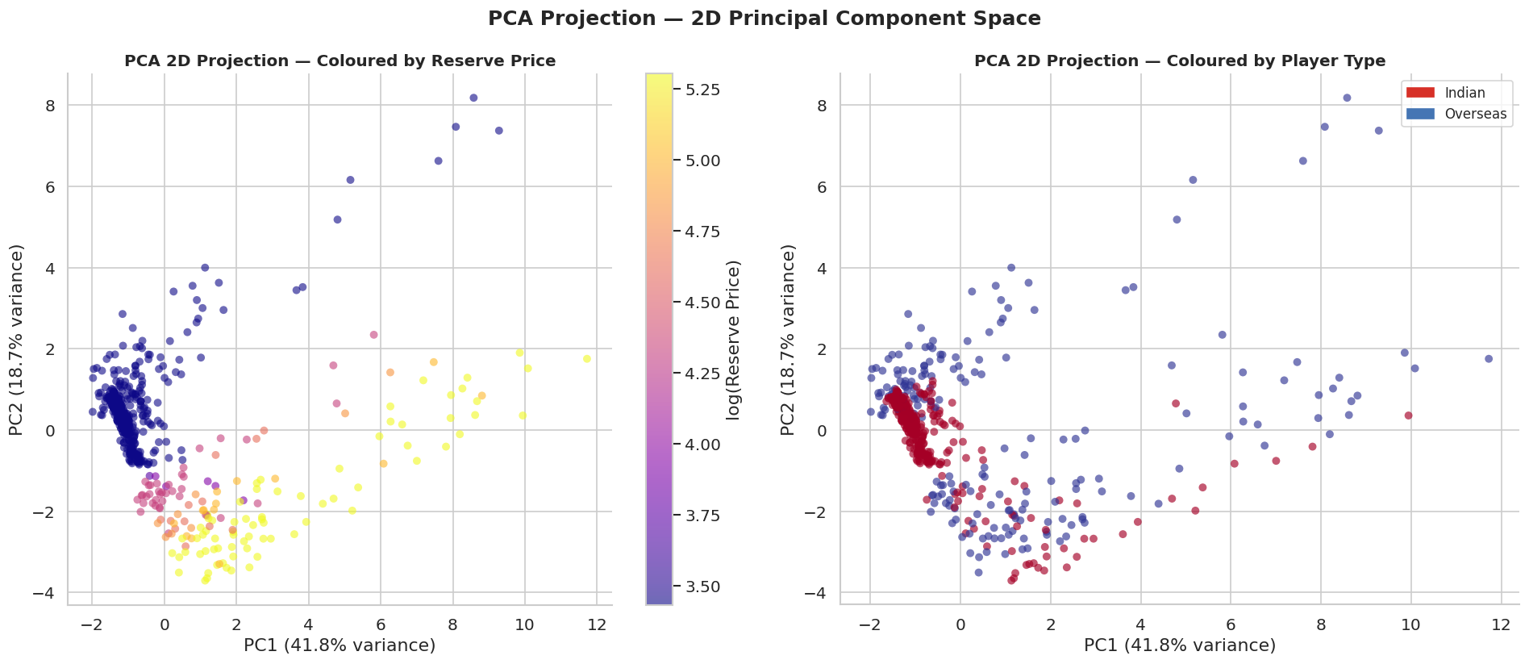

Code:
from mpl_toolkits.mplot3d import Axes3D

fig=plt.figure(figsize=(12,9))
ax=fig.add_subplot(111,projection='3d')

price_color=np.log1p(df["Reserve_Price_Numeric"].values[:len(X_pca)])

sc=ax.scatter(X_pca[:,0],X_pca[:,1],X_pca[:,2],
c=price_color,cmap='viridis',alpha=0.6,s=25)
plt.colorbar(sc,ax=ax,label='log(Reserve Price)',shrink=0.5)
ax.set_xlabel(f"PC1 ({explained[0]*100:.1f}%)")
ax.set_ylabel(f"PC2 ({explained[1]*100:.1f}%)")
ax.set_zlabel(f"PC3 ({explained[2]*100:.1f}%)")
ax.set_title("PCA — 3D Principal Component Projection",fontsize=14,fontweight='bold')
plt.tight_layout()
plt.show()

Visualization: PCA 3D Scatter Plot
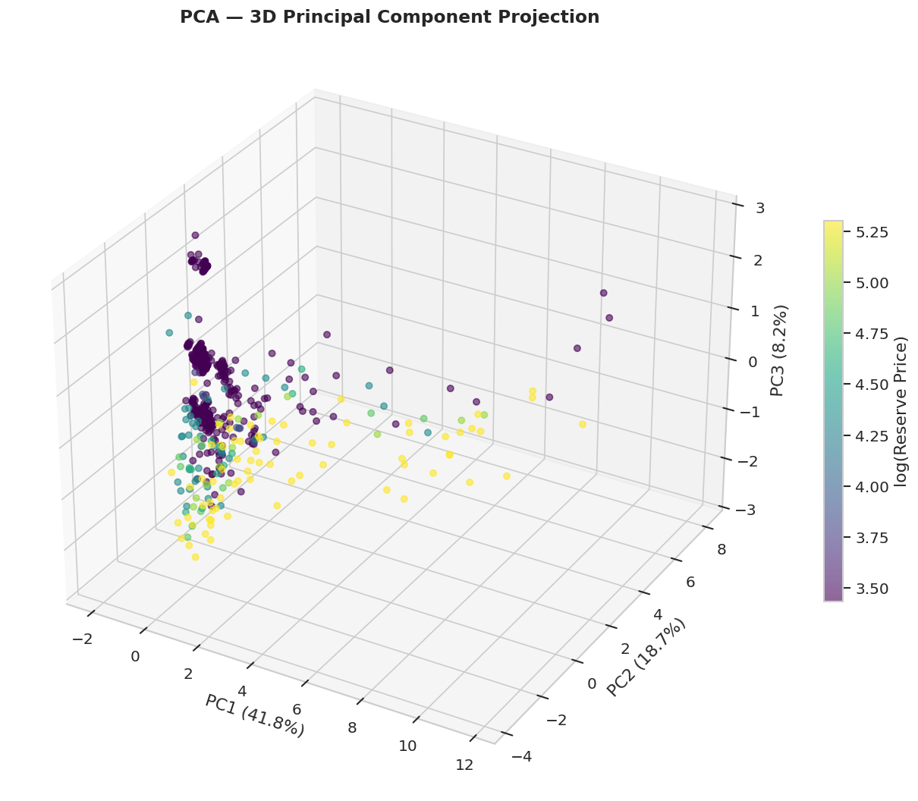

Code:
pca_2=PCA(n_components=2)
pca_2.fit(X_scaled)
loadings=pd.DataFrame(pca_2.components_.T,
index=df_numeric.columns,
columns=["PC1","PC2"])

top_features=loadings.abs().sum(axis=1).sort_values(ascending=False).head(10).index
loadings_top=loadings.loc[top_features]

fig,axes=plt.subplots(1,2,figsize=(15,7))

axes[0].barh(loadings_top.index,loadings_top["PC1"],
color=['#FF6B6B' if v>0 else '#4D96FF' for v in loadings_top["PC1"]],
edgecolor='white',linewidth=1)
axes[0].axvline(0,color='black',linewidth=0.8)
axes[0].set_title("PC1 — Feature Loadings (Top 10)",fontsize=13,fontweight='bold')
axes[0].set_xlabel("Loading Value")

axes[1].barh(loadings_top.index,loadings_top["PC2"],
color=['#6BCB77' if v>0 else '#FFD93D' for v in loadings_top["PC2"]],
edgecolor='white',linewidth=1)
axes[1].axvline(0,color='black',linewidth=0.8)
axes[1].set_title("PC2 — Feature Loadings (Top 10)",fontsize=13,fontweight='bold')
axes[1].set_xlabel("Loading Value")

plt.suptitle("PCA Component Loadings — Feature Contribution Analysis",fontsize=14,fontweight='bold')
plt.tight_layout()
plt.show()

Visualization: PCA Feature Loadings
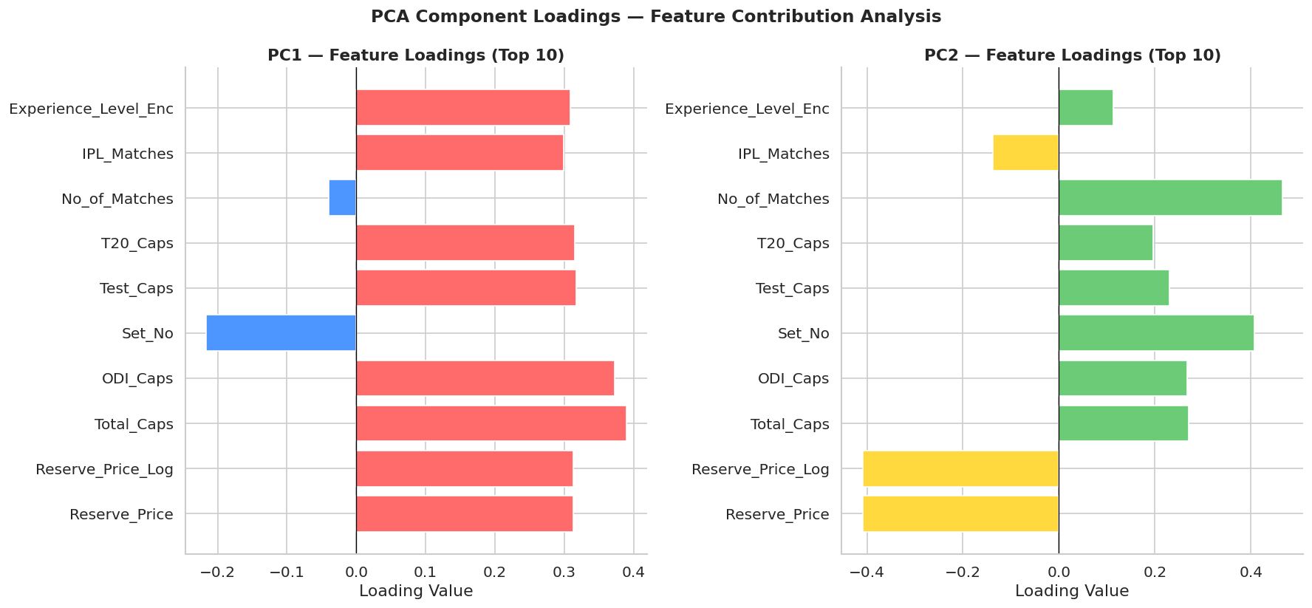
Team Contribution:

NAME | ROLL NUMBER | CONTRIBUTION
Harish M K | 24BAD031 | Implemented PCA on the dataset after scaling, selected relevant features, and analyzed principal components to understand variance distribution
Dinesh Kumar P | 24BAD021 | Interpreted explained variance ratio, evaluated the importance of components
Bala Harshini B | 24BAD015 | Created visualizations including scree plot and PCA scatter plots to represent dimensionality reduction results effectively.
Jeeva Dharan G | 24BAD046 | Documented PCA methodology, summarized key insights, and integrated findings into the report and presentation.

